**DUROPRO INFINITY ROOF SYSTEM**

**A SUSTAINABLE ROOF RESTORATION & REPLACEMENT SOLUTION**

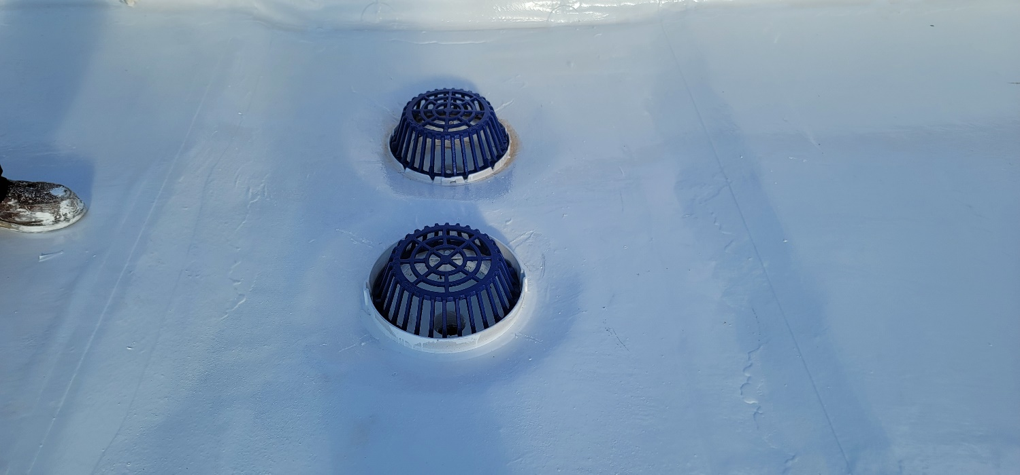

**ENERGY SAVINGS, INCREASED SERVICE LIFE, QUICK & EASY APPLICATION, LOWER COSTS, NO TEAR OFF & OUTSTANING WARRANTY PROTECTION!**

**TAKE THE RISK OUT OF**

**PROTECTING YOUR ASSETS!**

**AFTER**

**BEFORE**

**Our systems restore and maintain every type of commercial system that exists; including TPO, PVC, Hypalon, EPDM, Built-Up Roof Systems (BUR), Modified-Bitumen Roof Systems, Spray Applied Polyurethane Foam, other liquid-applied systems, metal, concrete, and other cementitious materials.**

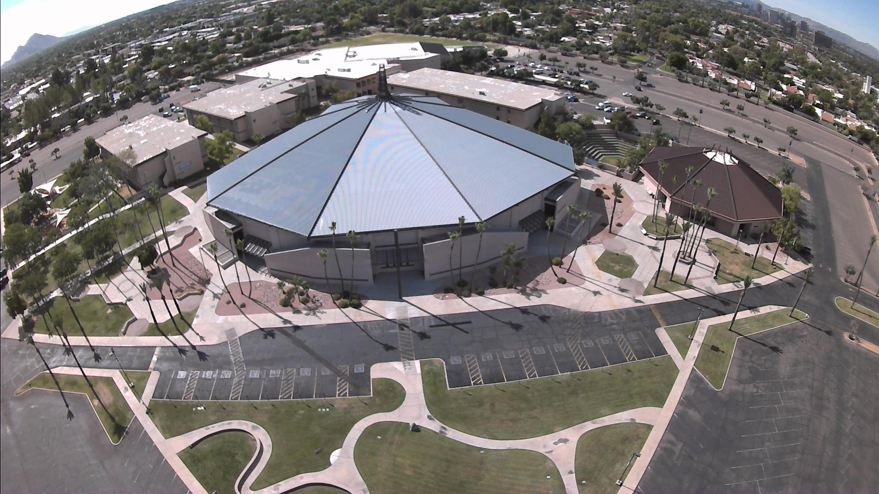

***OUR FULL PROTECTION SOLUTION***

Our DuroPro Infinity Roof System can be used in many situations, from restoring existing roofs to roof removal and replacement. We will make sure that this system is right for your building and needs. Our teams will do the full install correctly ensure it provides long-term service and durability.

**CALL OUR DEP TEAM** for infrared scanning and core testing, construction, condition and recommendation report, budget, project specifications, pre-construction meetings, project inspections during installation, final inspection, full roofing system warranty, long-term planned roofing programs!

**These before and after readings show the DuroPro Infinity Roof System can significantly lower rooftop temperatures. This can help keep your building cooler and more comfortable, leading to a potential reduction in the amount of energy that your facility uses.**

***BENEFITS OF PUTTING ON YOUR FINAL ROOF***

With these elevated qualities for your roof, you don’t need to look further than the

DuroPro Infinity Roof System when you need to revitalize a roof.

Low life-cycle cost roof system * Excellent cold-weather flexibility, tensile strength and elongation properties * Low odor * Weathers well * Highly reflective * Easy to maintain, keeping them sustainable for the long haul * FM Global fire and wind rated *

UL fire rated * Resistance to chemicals, traffic, hail and mold/mildew/ fungus

**FULL LABOR AND MATERIAL WARRANTIES UP TO 30 YEARS**

**COMMERCIAL – INDUSTRIAL – OFFICE**

***FOR MORE INFORMATION CALL***

***AN DEP REPRESENTATIVE!***

***888-253-6755***

**2252 North 23rd Drive, Phoenix, AZ 85009**

**(602) 739-3425**

**www.duroproengineeredproducts.com**

**PROUDLY COMPLETED PROJECTS**

**Phoenix Children’s Hospital * Mayo Clinic Scottsdale AZ * North Phoenix Baptist Church * Calvary Chapel * Tyson Foods * MidWestern University * Missouri Western University * Northern Arizona University * City of Chandler**